PUNEETH A
1NT20IS408
BIG DATA LAB

Show dbs

> show dbs
Irfan 0.000GB
admin 0.000GB
config 0.000GB
local 0.000GB
puneeth 0.000GB
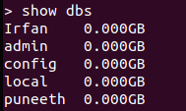

CREATING DB

use 1NT20IS408
switched to db 1NT20IS408
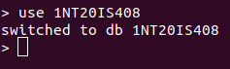

INSERT ONE COMMAND:

db.puneeth.insertOne({name:"PUNEETH",USN:"1NT20IS408",dept:"ISE"})
{
"acknowledged" : true,
"insertedId" : ObjectId("6291c1082d9ad2c69da4cea2")
}
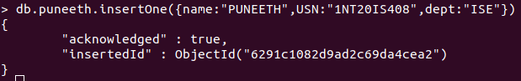

INSERT MANY COMMANDS:

db.puneeth.insertMany([{name:"Adarsh",USN:"1NT20IS400",dept:"ISE"},
... {name:"Irfan",USN:"1NT20CS404",dept:"ISE"},
... {name:"Nikhil",USN:"1NT20CS407",dept:"ISE"}])
{
"acknowledged" : true,
"insertedIds" : [
ObjectId("6291c2382d9ad2c69da4cea3"),
ObjectId("6291c2382d9ad2c69da4cea4"),
ObjectId("6291c2382d9ad2c69da4cea5")
]
}

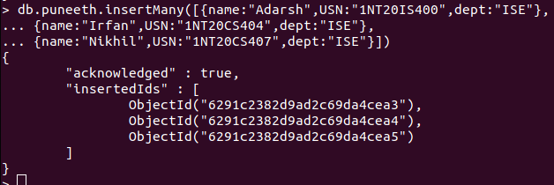

OUTPUT OF INSERTING COMMAND:

db.puneeth.find()
{ "_id" : ObjectId("6291c1082d9ad2c69da4cea2"), "name" : "PUNEETH", "USN" : "1NT20IS408", "dept" : "ISE" }
{ "_id" : ObjectId("6291c2382d9ad2c69da4cea3"), "name" : "Adarsh", "USN" : "1NT20IS400", "dept" : "ISE" }
{ "_id" : ObjectId("6291c2382d9ad2c69da4cea4"), "name" : "Irfan", "USN" : "1NT20CS404", "dept" : "ISE" }
{ "_id" : ObjectId("6291c2382d9ad2c69da4cea5"), "name" : "Nikhil", "USN" : "1NT20CS407", "dept" : "ISE" }

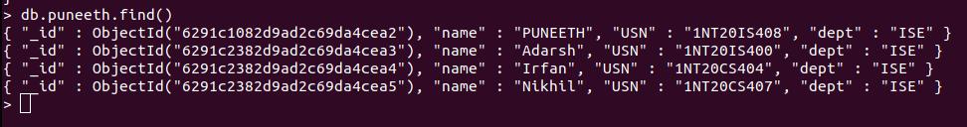

OUTPUT USING PRETTY COMMAND:

> db.puneeth.find().pretty();
{
"_id" : ObjectId("6291c1082d9ad2c69da4cea2"),
"name" : "PUNEETH",
"USN" : "1NT20IS408",
"dept" : "ISE"
}
{
"_id" : ObjectId("6291c2382d9ad2c69da4cea3"),
"name" : "Adarsh",
"USN" : "1NT20IS400",
"dept" : "ISE"
}
{
"_id" : ObjectId("6291c2382d9ad2c69da4cea4"),
"name" : "Irfan",
"USN" : "1NT20CS404",
"dept" : "ISE"
}
{
"_id" : ObjectId("6291c2382d9ad2c69da4cea5"),
"name" : "Nikhil",
"USN" : "1NT20CS407",
"dept" : "ISE"
}

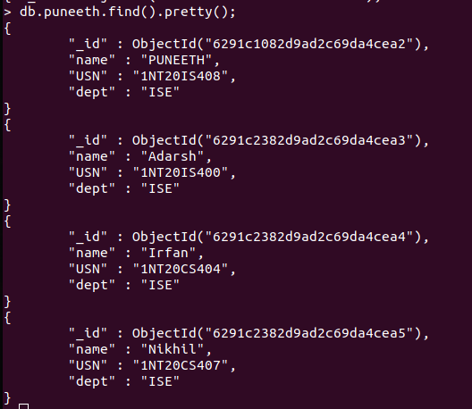

UPDATE ONE AND UPDATE MANY COMMAND:

> db.puneeth.updateOne({name:"PUNEETH"},{$set:{name:"Shilpa"}})
{ "acknowledged" : true, "matchedCount" : 1, "modifiedCount" : 1 }

OUTPUT OF UPDATEONE

> db.puneeth.find()
{ "_id" : ObjectId("6291c1082d9ad2c69da4cea2"), "name" : "Shilpa", "USN" : "1NT20IS408", "dept" : "ISE" }
{ "_id" : ObjectId("6291c2382d9ad2c69da4cea3"), "name" : "Adarsh", "USN" : "1NT20IS400", "dept" : "ISE" }
{ "_id" : ObjectId("6291c2382d9ad2c69da4cea4"), "name" : "Irfan", "USN" : "1NT20CS404", "dept" : "ISE" }
{ "_id" : ObjectId("6291c2382d9ad2c69da4cea5"), "name" : "Nikhil", "USN" : "1NT20CS407", "dept" : "ISE" }
>

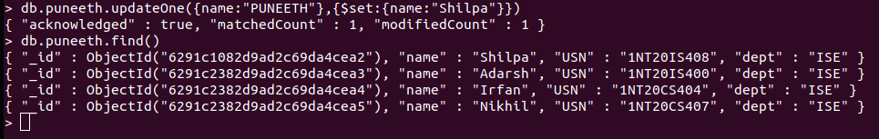

DELETE COMMAND:

db.puneeth.deleteMany({name:"Shilpa"})
{ "acknowledged" : true, "deletedCount" : 1 }

OUTPUT OF DELETE COMMAND:

> db.puneeth.find()
{ "_id" : ObjectId("6291c2382d9ad2c69da4cea3"), "name" : "Adarsh", "USN" : "1NT20IS400", "dept" : "ISE" }
{ "_id" : ObjectId("6291c2382d9ad2c69da4cea4"), "name" : "Irfan", "USN" : "1NT20CS404", "dept" : "ISE" }
{ "_id" : ObjectId("6291c2382d9ad2c69da4cea5"), "name" : "Nikhil", "USN" : "1NT20CS407", "dept" : "ISE" }
>

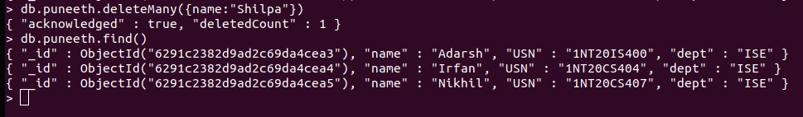

AGGREGATE COMANDS:

db.puneeth.insertMany([{_id:0,name:"Pepperoni",size:"small",price:15,quantity:10,date:ISODate("2021-03-13T08:14:30Z")},
... {_id:1,name:"Pepperoni",size:"medium",price:20,quantity:20,date:ISODate("2021-03-13T09:13:24Z")},
... {_id:2,name:"Pepperoni",size:"large",price:21,quantity:30,date:ISODate("2021-03-17T09:22:12Z")},{_id:3,name:"Cheese",size:"small",price:12,quantity:15,date:ISODate("2021-03-13T11:21:39.736Z")},
... {_id:4,name:"Cheese",size:"medium",price:13,quantity:50,date:ISODate("2022-01-12T21:23:13.331Z")},
... {_id:5,name:"Cheese",size:"large",price:14,quantity:10,date:ISODate("2022-01-12T05:08:13Z")}])
{ "acknowledged" : true, "insertedIds" : [ 0, 1, 2, 3, 4, 5 ] }

OUTPUT OF AGGREGARE:

db.puneeth.aggregate([{$match:{size:"large"}},{$group:{_id:"$name",totalQuantity:{$sum:"$quantity"}}}])
{ "_id" : "Pepperoni", "totalQuantity" : 30 }
{ "_id" : "Cheese", "totalQuantity" : 10 }
>

